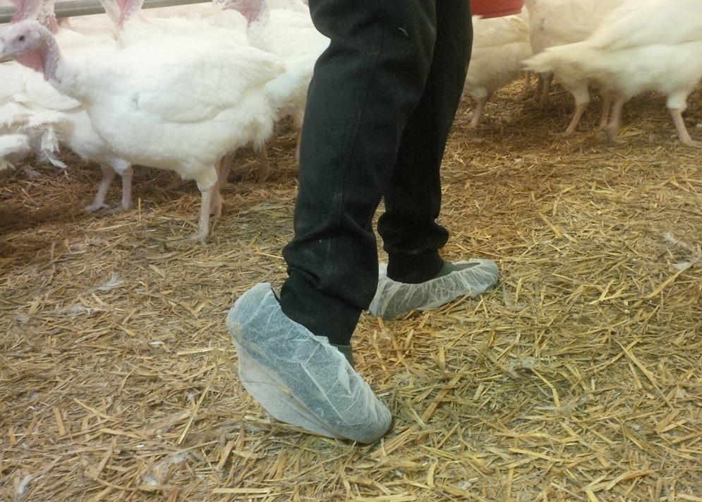

Supporting document
Checklist to determine salmonella entry sources in fattening poultry stocks
Stand: 15.11.2021

Area | Criteria | Entry risk
 |  | low | increased
Operational environment | Are there additional poultry farms within short distance (ca. 1km) of the company? | No | Yes
 | Do third parties bring out bird droppings to surrounding areas? | No | Yes
 | Are other animals (also other poultry, fancy fowl, or domestic birds) kept on the farm, apart from the presently reared poultry. | No | Yes
 | Is the farm clean and tidy? | Yes | No
 | Are the delivery points of feed and animals and the shipping points of droppings and animals paved? | Yes | No
 | Are the points clean? | Yes | No
 | Is the stable wall free from obstacles up to a height of 1m on the exterior? | Yes | No
 | Is the premises around the stable densely greened? | No | Yes
 | Are the access roads to the farm buildings paved and can be disinfected? | Yes | No
 | Are droppings from a previous feeding pass stored within a radius of 300m? | No | Yes
 | Are there objects in the white area of the farm terrain that are not necessary for operations? | No | Yes
Building | Is there a frequent cleaning (at least weekly) of the anteroom and the encompassed inventory? | Yes | No
 | Is the stable anteroom dusty, filled with cobwebs and/or damp? | No | Yes
 | Is the floor event and without cracks? | Yes | No
 | Do non-company individuals have access to the stable area? | No | Yes
 | Are intake vents protected from entry by birds/vermin? | Yes | No
Staff hygiene | Is there a physical separation in the black and white area? | Yes | No
 | Is a visitor's log kept? | Yes | No
 | Is separate footwear used for each stable? | Yes | No
 | Is a hygiene gate available in the company? | Yes | No
 | Do you use a hygiene gate or a changing room? | Yes | No
 | Do non-company individuals have access to the stable area? | No | Yes
 | Do visitors wash their hands before entering the stable? | Yes | No
 | Does the water standpipe function? | Yes | No
 | Are clean overalls in different sizes available or are throw-away overalls in different sizes available? | Yes | No
 | Are annual fecal specimens taken from staff and checked? | Yes | No
 | Are clean boots with slick soles in different sizes available or are disposable overshoes available? | Yes | No
 | Do the users use these facilities? | Yes | No
 | Is there a possibility to clean and disinfect the boots? | Yes | No
 | Is the disinfection bath (if available) cleaned daily and refilled? | Yes | No
Cleaning and disinfecting the stable | Are the droppings and consumable supplies removed in such a way that they not get in contact with other feeding groups? | Yes | No
 | Are the droppings removed immediately after the removal from the building and the stable deep cleaned and disinfected? | Yes | No
 | Is the stable wet cleaned and disinfected before being repopulated? | Yes | No
 | Are DVG-approved disinfectants used for disinfection? | Yes | No
 | Cleaning the inside of air ventilation ducts? | Yes | No
 | Are the stable surroundings in the exterior parts cleaned? | Yes | No
 | Does a frequent cleaning (after each pass) of the exterior parts take place? | Yes | No
 | Are the stable surroundings disinfected after each feeding? | Yes | No
 | Does a hygiene inspection take place after each disinfection? | Yes | No
 | Is the disinfection performed by a specialized company? | Yes | No
 | Do the hygiene inspections show an efficiency of the cleaning? | Yes | No
Access of other animals to the stable area | Do dogs and cats have access to the stable? | No | Yes
 | Do birds have access to the stable? | No | Yes
Vermin/rodent control | Is a vermin/rodent control plan in place? | Yes | No
 | Do people work as per the company-own vermin/rodent control plan? | Yes | No
 | Is the vermin/pest control performed by trained personnel? | Yes | No
 | Are increased amounts of mice or rats seen on the farm? | No | Yes
 | Have there been fly or beetle problems in the stables? | No | Yes
 | Do problems with mites exist at your farm? | No | Yes
 | Are remainders (e.g., droppings, feed) from a previous feeding pass available on the farm? | No | Yes
 | In the vermin/pest control plan is it made evident which agents in which dosage are used where and when? | Yes | No
Transport to and from of poultry | On the embark point is company-owned clothing as well as company-owned shoes available? | Yes | No
 | Are the chicks free of salmonella? | Yes | No
 | Does information on the salmonella status of the previous group exist? | Yes | No
 | Has a salmonella inspection been performed at the end of rearing? | Yes | No
Handling of carcasses | Are dead animals removed from the stable on a daily basis? | Yes | No
 | Are the cadavers stored in a closed and chilled container? | Yes | No
 | Do cats, dogs, and vermin have access to the carcass storage? | No | Yes
 | Is the carcass storage point cleaned after removal? | Yes | No
 | Is the carcass storage point disinfected after removal? | Yes | No
 | Does the carcass storage take place outside of the stable area? | Yes | No
 | Is the carcass storage point paved? | Yes | No
 | Is the carcass storage point waterproof? | Yes | No
Feed | Are self-produced feed stuffs added to the feed? | No | Yes
 | Is the feed acidified (only relevant for self-mixers)? | Yes | No
 | Are feed residues removed from the silo after each rearing pass? | Yes | No
 | Is the remaining feed removed from the feed system after the removal from the stable? | Yes | No
Potable water | Was the potable water system cleaned and disinfected during vacancy period? | Yes | No
 | Is the water inspected annually? | Yes | No
 | Were the samples for the bacteriological potable water inspection taken at the endpoint of the potable water system? | Yes | No
 | In the event of deviations from the valid norm, were corrective actions initiated and the success of the implemented action verified through a new inspection? | Yes | No
Litter | Is the straw inventory protected against rodents and weather impact? | Yes | No
 | Is the quality of the used litter okay (no moldiness etc.)? | Yes | No
Dung | Are the droppings removed after each feed pass? | Yes | No
 | Is the storage location covered? | Yes | No
Joint use of machines and devices | Are jointly-used machines used? | No | Yes
 | Are jointly-used devices and machines cleaned/disinfected sufficiently? | Yes | No
Salmonella inspection | Has a salmonella infection been detected? | No | Yes
 | Has the entrepreneur been informed by the upstream level (breeder/brooder) about the results of a salmonella inspection? | Yes | No
Actions in the event of a present salmonella infection | Was the stable double cleaned and disinfected clearing following the detection of a salmonella infection? | Yes | No
 | Was the infected poultry group logistically loaded at the poultry farmer? | Yes | No
 | Did a success control take place after the cleaning and disinfection? | Yes | No
Biogas systems | Is the biogas system loaded with dropping/liquid manure from other companies? | No | Yes

Documentation of the initiated actions
Description of the action | Date

Place, Date Signature consulting veterinary/ Signature for company
Farm manager

________________ ______________________________ _________________________

Supporting document
Checklist to determine salmonella entry sources in fattening poultry stocks

QS Fachgesellschaft Geflügel GmbH
Managing Director: Dr. A. Hinrichs

Schwertberger Straße 14, 53177 Bonn
T +49 228 35068 -0
F +49 228 35068 -10
E info@q-s.de

Photo: QS

q-s.de

